Instructions for the submission of papers in the system
Open Journal Systems 3.1

UPH Scientific Journal
Administration and Management Issue

Submission of the article by the author is possible for a registered user. For this purpose, the author selects the TEXT SENDING option (see label 1 in Fig. 1) and proceeds to login (see label 2 in Fig. 2) or - if you do not have an account in the system, you may choose the Register option (see label 3 in Fig. 1).
3
2
1

Figure 1. Login and registration view when submitting an article
During registration, the author shall fill in the following form, in particular the fields indicated by label 1 in Figure 2.
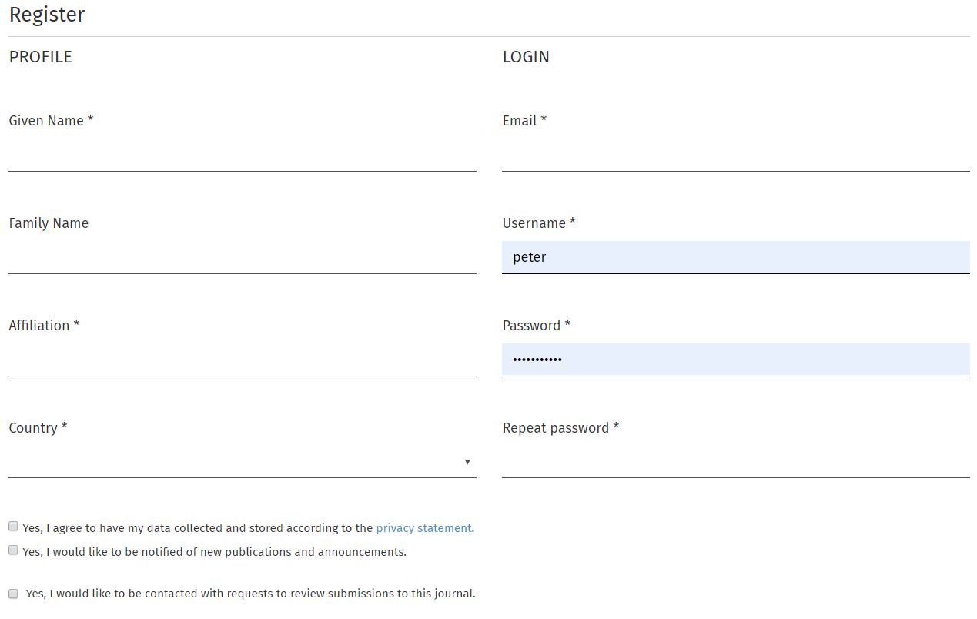
2
1
Figure 2. Author registration form
Fields marked with * are obligatory. The author must also agree to the collection and storage of data in accordance with the privacy policy (see label 2 in Figure 2). Optionally, the author may agree to be notified of new publications and announcements. In addition, the author may agree to receive requests from the editor-in-chief of the journal for article reviews for this journal. After giving this consent, the author is asked to provide a brief overview of research interests. After completing the registration, the author can log into the system.
After logging into the system, the user is directed to the application panel. A list of entries will appear here (if they have already been posted). To submit a new article, click on New submission (see label 1 in Figure 3).
1
Figure 3. Application submission and new article submission option
After selecting this option, the following panel will open (see Fig. 4). It consists of five steps (sections) that the author must complete in order to submit an article.

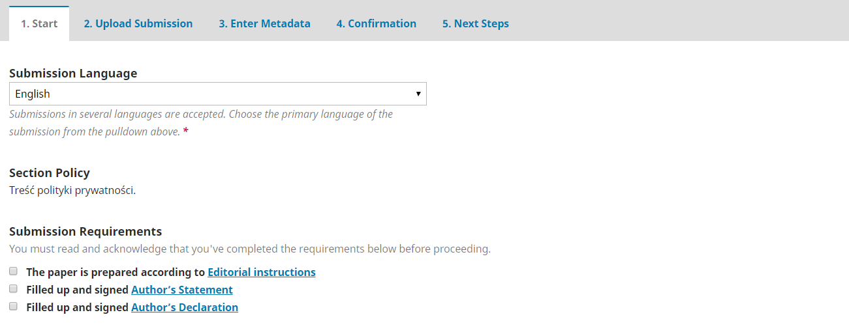
Figure 4. Article submission panel: language selection and submission checklist
In the first step, the author is asked to choose the language of the submitted text (select English). Then the user marks the requirements in the checklist for the article that must be met (these options must be checked).
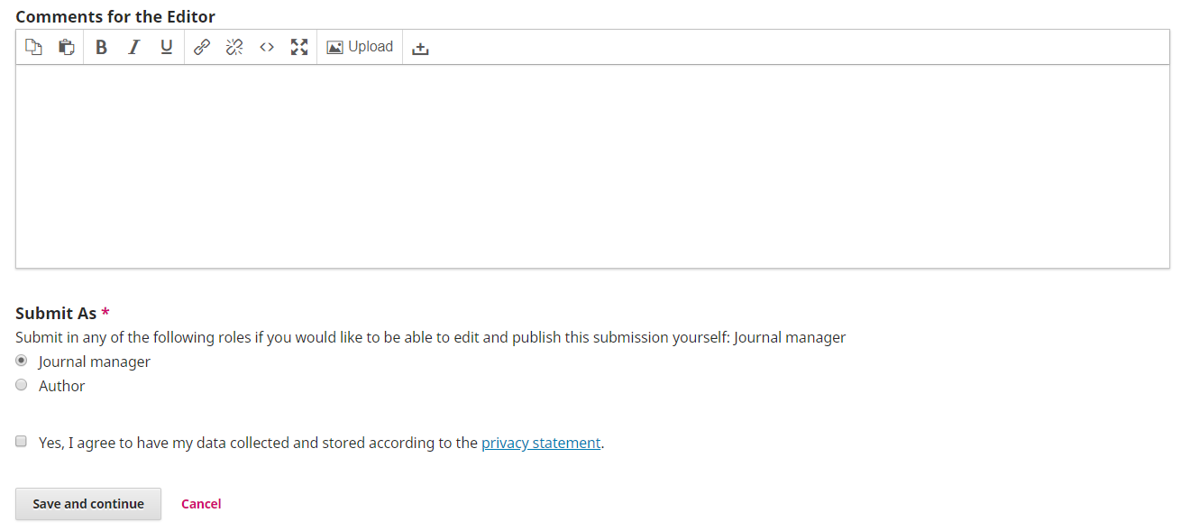
Figure 5. Article submission panel: message for the editor
Later in this section, the author optionally introduces a message for the editor and consents to be contacted regarding this application; and consents to the collection and storage of data. Then the author clicks Save and Continue. The next section window will then appear.
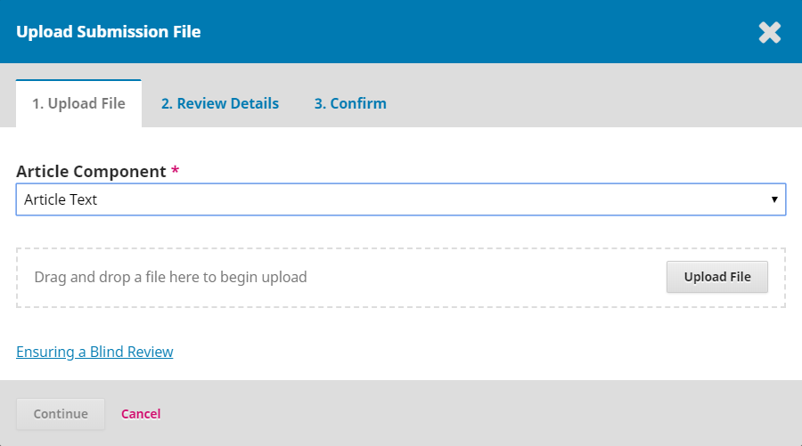
1
2
Figure 6. Article submission panel: file upload
In the second section, the author sends files related to the submission of the article (see Fig. 6). These are files:
• Front Page,
• Article Text,
• Author's Statement,
• Author's Declaration.
Each file is entered separately. To enter a file, select the appropriate Item (see label 1 in Fig. 6) and clicking the Upload file button (see label 2 in Fig. 6). Then a dialog box will open in which you can specify the file to be transferred to the system.
By clicking the Continue button, the author proceeds to viewing the details of the saved file in the system (see Fig. 7) and confirms this operation (see Fig. 8).

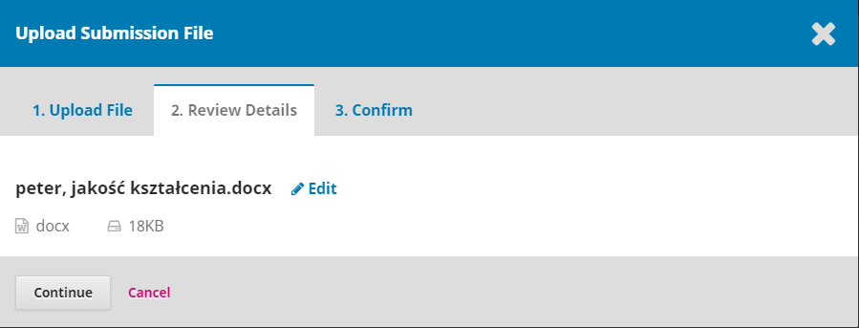
Figure 7. Article submission panel: details of the uploaded file
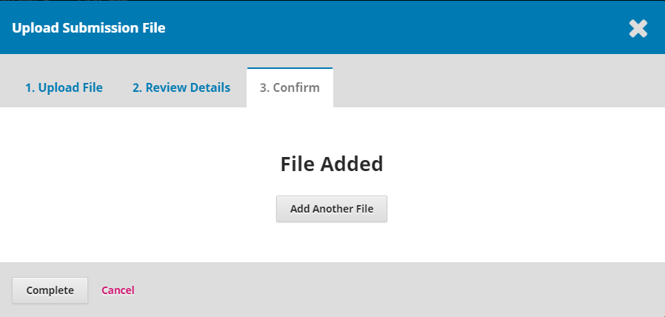
Figure 8. Article submission panel: confirmation of sending the file
This operation should be repeated for other files sent in the notification. To do this, select the option Upload file as shown in Fig. 9 (see label 1).
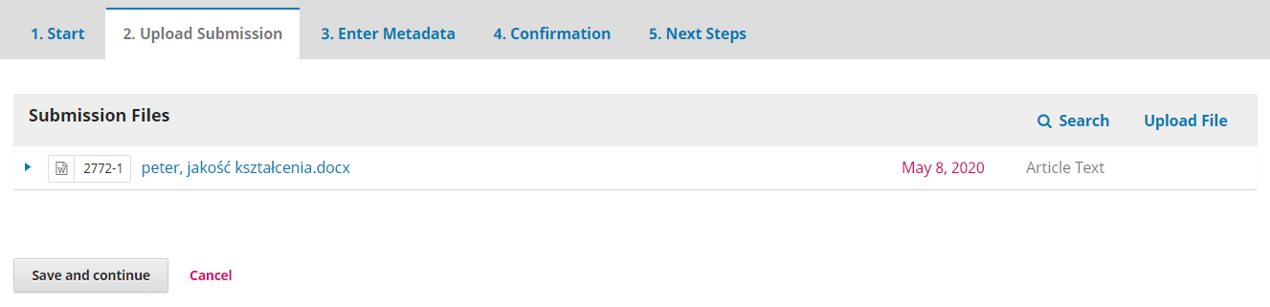
1
Figure 9. Uploading the next file
Then, the transfer file window will appear as shown in Fig. 6. We perform the same operations carried out for the previous file.
After submitting the required files, the author proceeds to the third section (see Figure 10) where the metadata of the submitted article is entered. The necessary data here are the Title and Abstract fields.
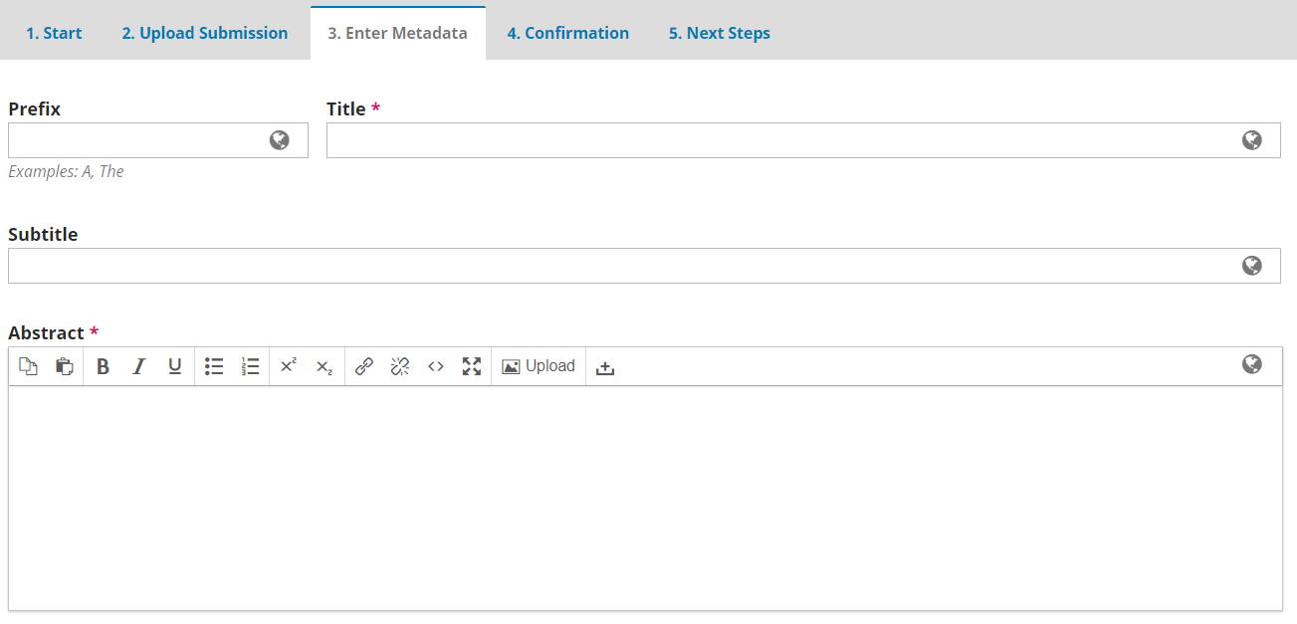
Figure 10. Article submission panel: entering metadata part 1
Later in this section (see Figure 11), supplement the author's data and add co-authors of the publication.
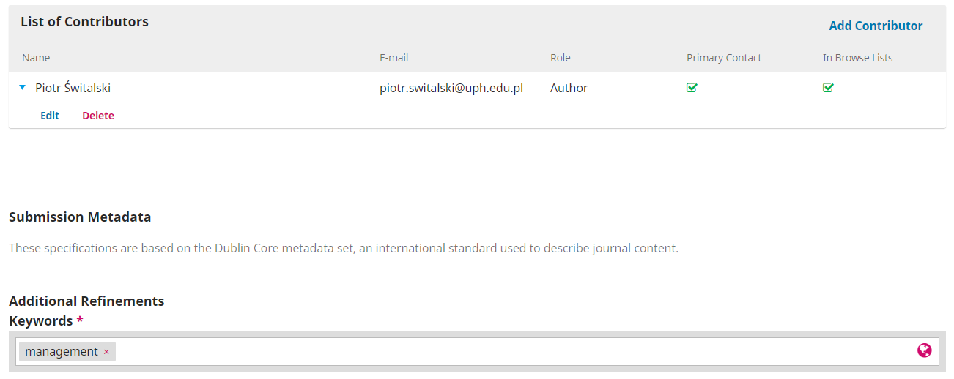
4
3
1
2
Figure 11. Article submission panel: entering metadata part 2
The first stage of completing the data involves adding the missing data of the author submitting the article. In order to do this, expand the triangle icon (see label 1 in Fig. 11), and then click the Edit link (see label 2 in Fig. 11).
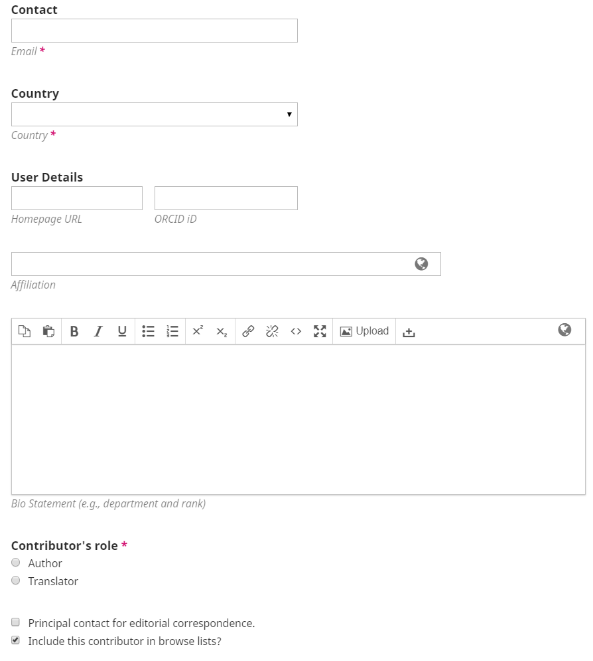
2
1
Figure 12. Article submission panel: entering author data
The author data window will then appear. Please complete the ORCID field indicated by the label 1 in Fig. 12 and the Affiliation field indicated by label 2 in Fig. 12.
Then go to adding co-authors (if they exist). Adding a co-author begins by selecting the Add co-author option (see label 3 in Fig. 11). The window for defining the co-author of the article will open (see Fig. 13). The most important items are the fields Name, Surname, Contact and Country (see label 1 in Fig. 13). They must be completed.
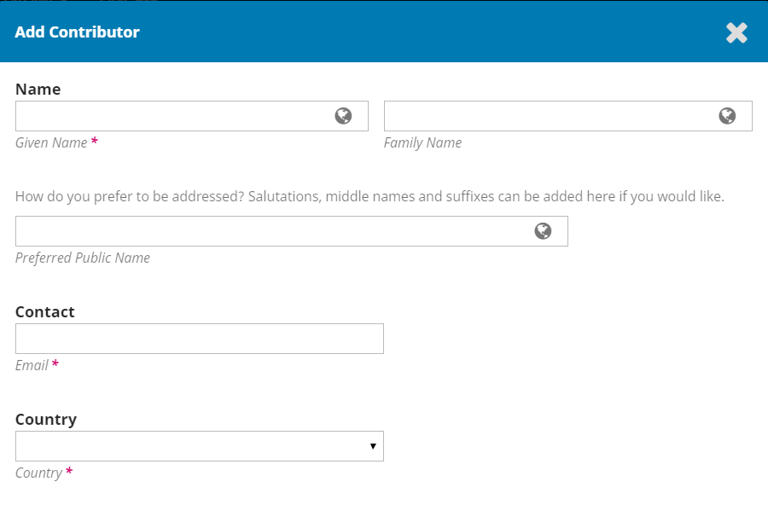
1
Figure 13. View of adding a co-author part 1
It is mandatory to fill in the fields related to the ORCID of the co-author (s) and his / her affiliation (see label 1 in Figure 14). It is also necessary to define the role of the co-author. The most common situation will be the Author selection and the possible selection of this author as the Main Contact Person (see label 2 in Figure 14).
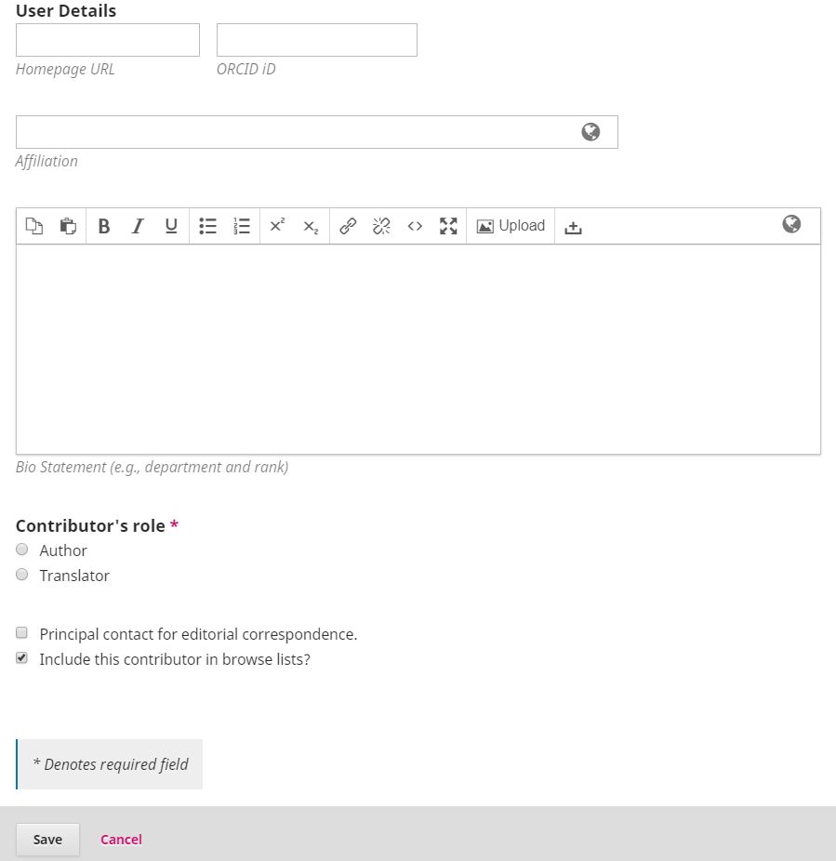
2
1
Figure 14. View of adding a co-author part 2
After adding all co-authors, enter keywords - see label 4 in Fig. 11. After confirming the data (Save and Continue button), the author should then proceed to confirm the submission of the article (see Fig. 15).

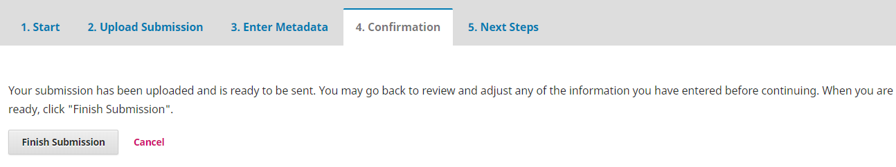
Figure 15. Article submission panel: confirmation of the submission by the author
By clicking Finish, the text submission process is completed. The author confirms the previously entered data and the submitted article is saved in the system.

Figure 16. Article submission panel: summary
In the next section (see Fig. 16) the author can review the application, submit another text, or return to the work panel.

After completion of activity, log out of the system.

